Simulation sensitivity analysis
School cutoff
- SA1: peaked infectiousness profile
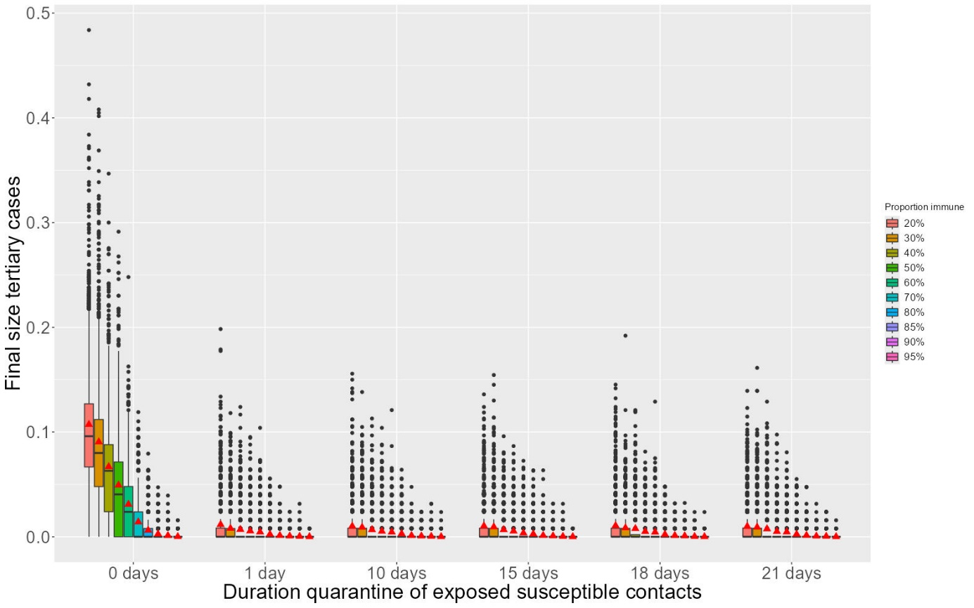
- SA2: constant incubation period of 20 days + peaked infectiousness profile
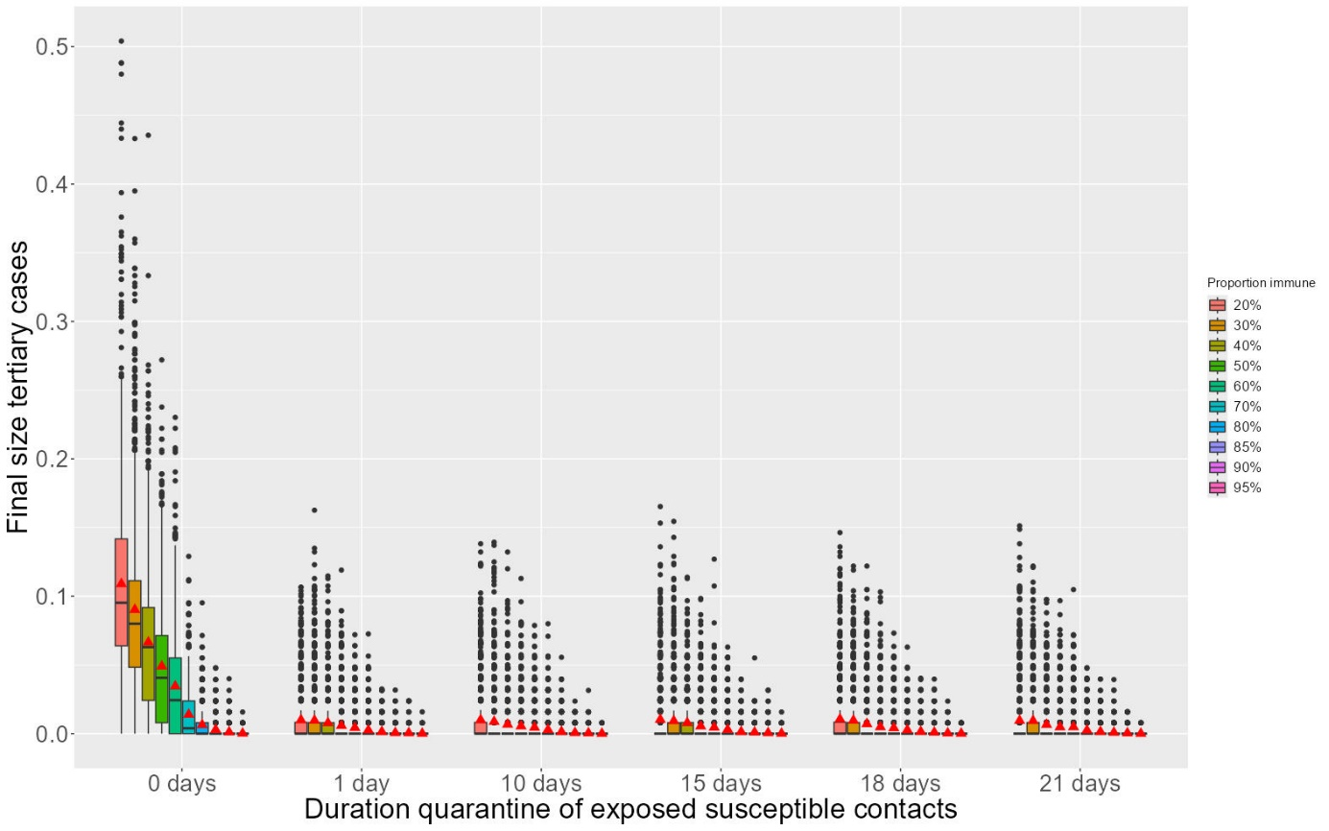

- SA3: constant incubation period of 20 days + constant infectiousness profile
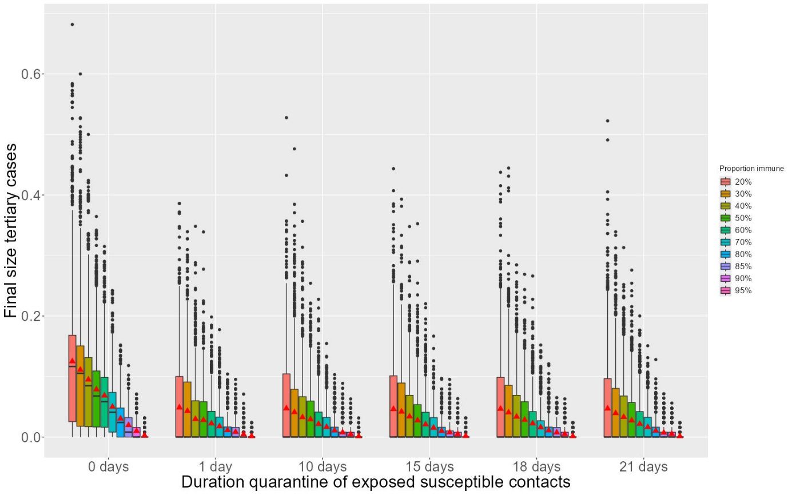
- SA4: only isolating contacts once
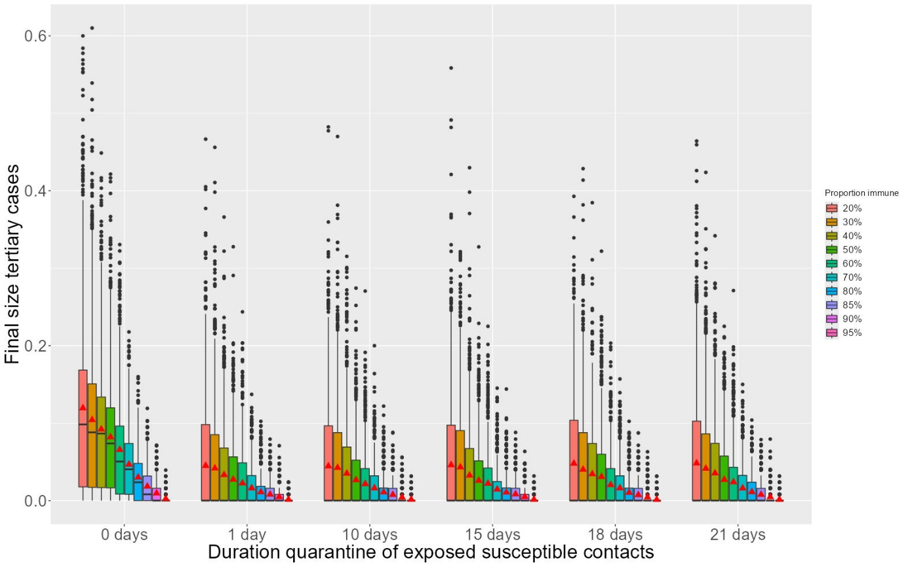

- SA5: unrealistically high R0 of 25 transmission potential q = 1

- SA6: unrealistically low R0 of 5

